5.112: a) For the tires not to lose contact, there must be a downward force on the tires. Thus, the (downward) acceleration at the top of the sphere must exceed mg, so 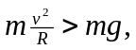 and 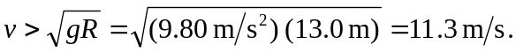
b) The (upward) acceleration will then be 4g, so the upward normal force must be

